Safety: All safety glasses and appropriate safety apparel is to be worn at all times.

Purpose or Objective: The purpose of this procedure is to define maintenance responsibilities as it relates to preparing the plant for cold weather months and support production. This procedure is to be completed the week after shutdown in October (typically October 12-23rd timeframe) and then reversed the last week of April (typically April 20-30th timeframe).

Procedure: The proper process to prepare the plant for cold weather as it relates to Maintenance is as follows:

- Notify all affected employees that the cold weather procedures are being put into effect.
- Check heat trace tape in the water recovery room and confirm that trace is plugged in and working properly to protect the water recovery system.

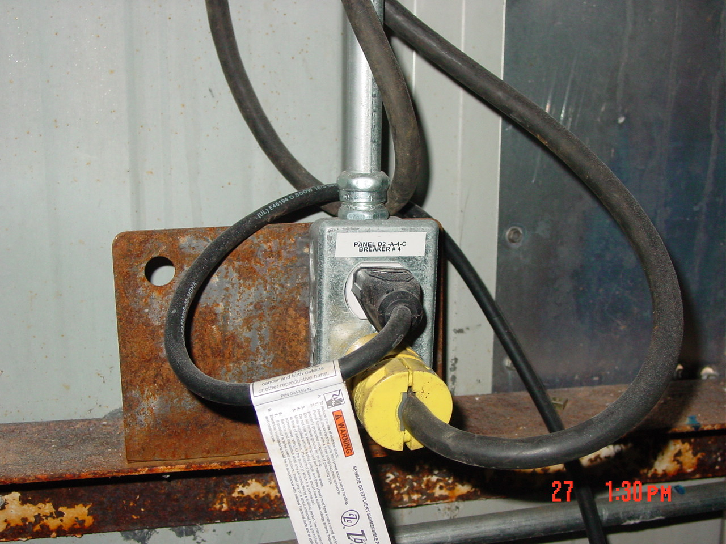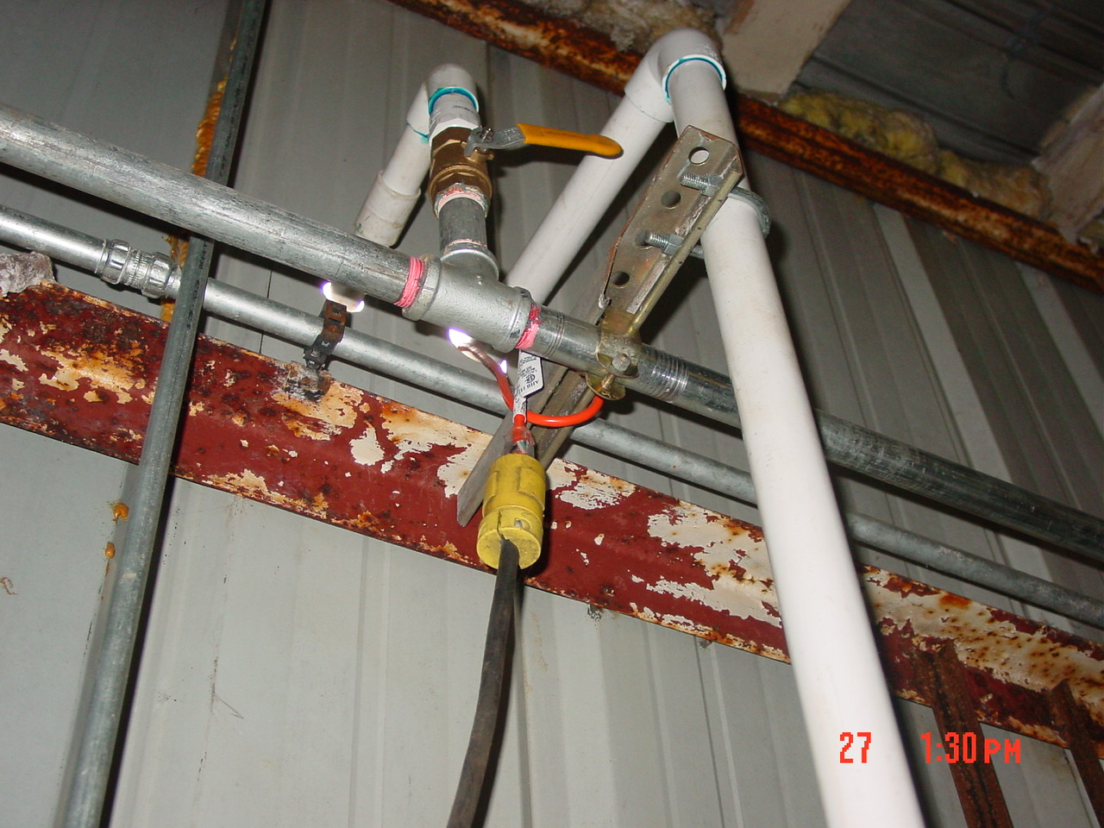

- Unlock and check heat trace tape on the water line feeding the Eyewash station at the
Acid unload station for the Railroad platform. There are two connections and both are expected to be working properly to ensure water supply to the Acid unload area.

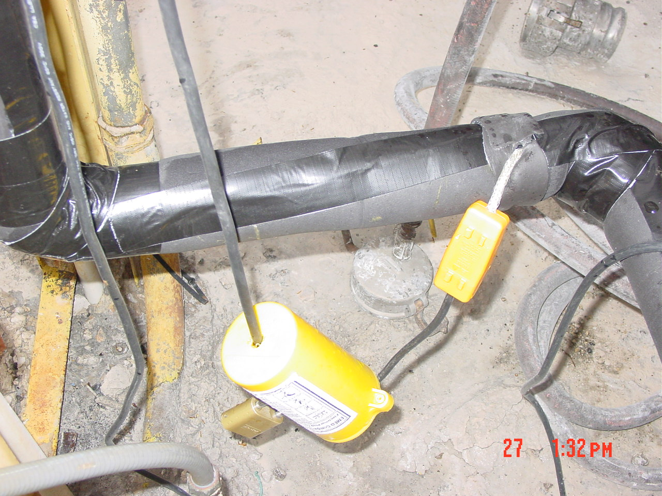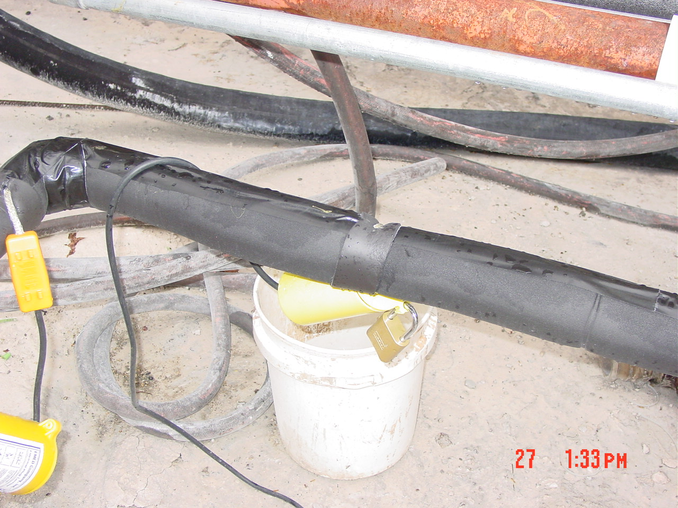

- Check heat trace is working properly on the eyewash station in the back lot servicing the acid tanks and the back lot area. Depress the red button chest high to determine if the heat trace is working properly.

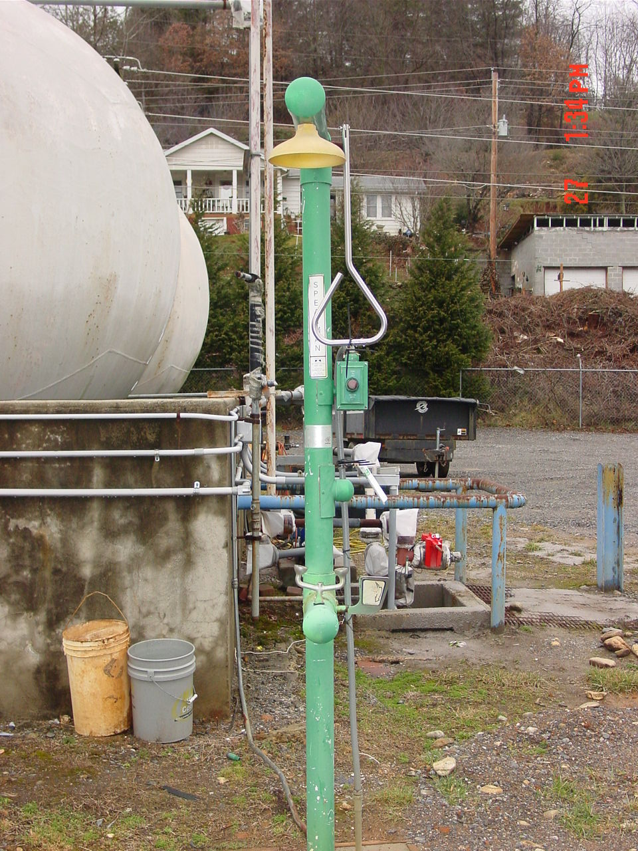

- Water line that supplies water to the lower warehouse should be cut off, line
pressurized to clear water out, and then locked out for duration of cold weather operation. The lockout is located outside the door on the second floor above the break room.

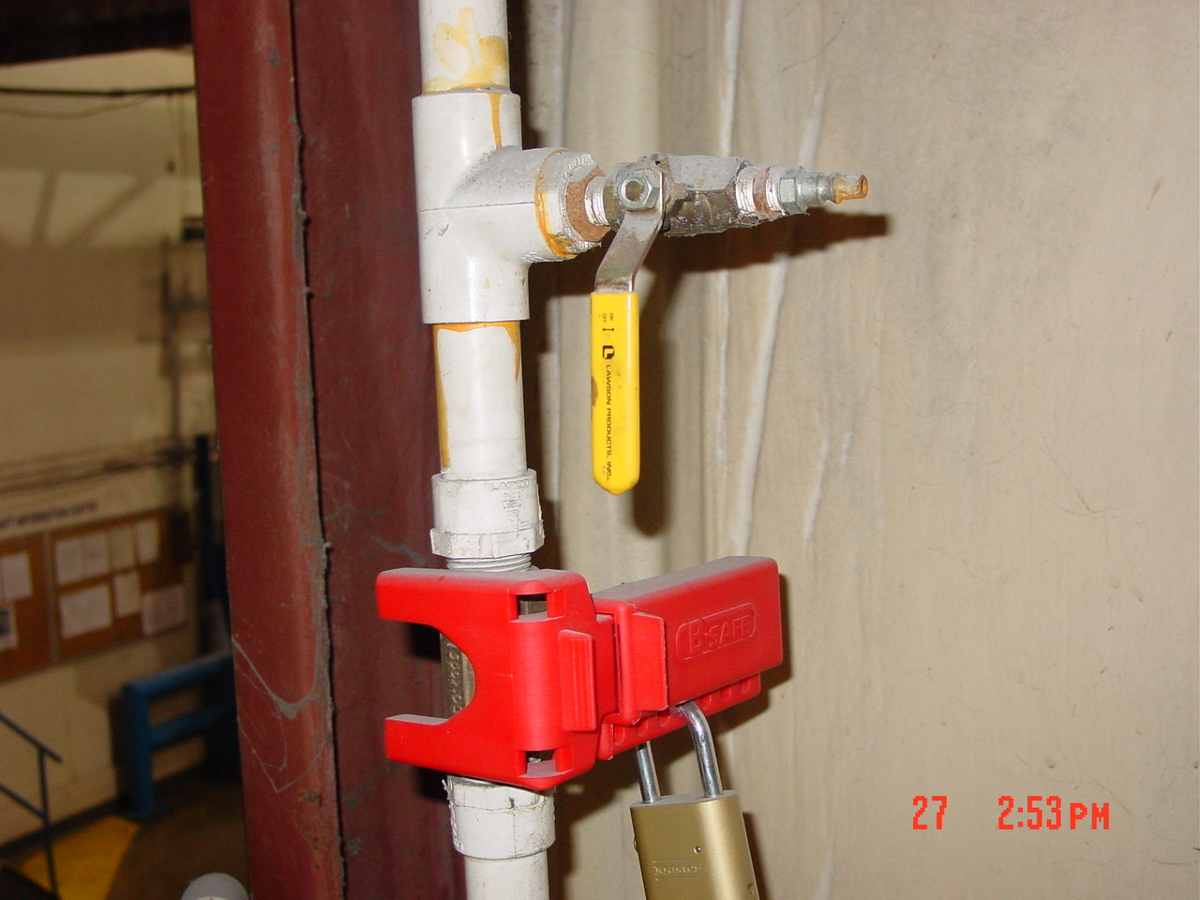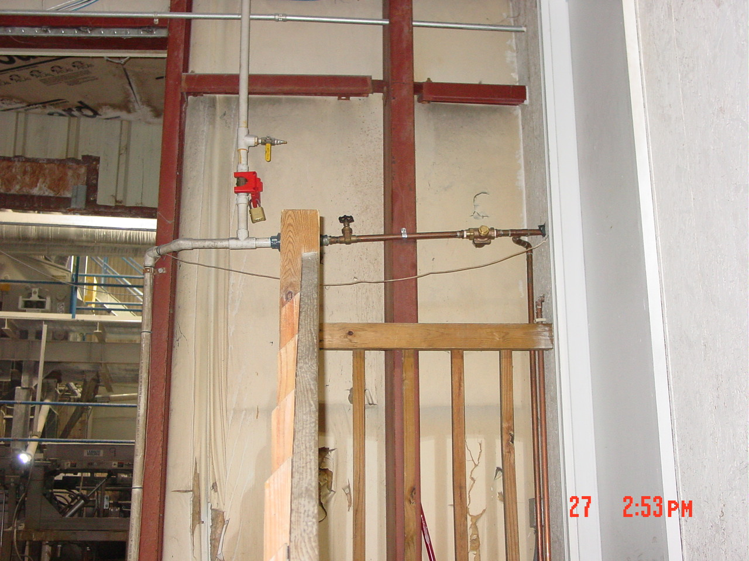

- This procedure should be reversed in the spring (April timeframe) with Production
being notified that the cold weather processes are being reversed for warm weather

TRAINING DOCUMENTATION

 | EMPLOYEE | TITLE | SIGNATURE | DATE
1
2
3
4
5
6
7
8
9
10
11
12
13
14
15
16
17
18
19
20
21
22
23
24
25
26
27
28
29

Revision  Number | Revision  Date | Revision  Author | Revision Description
00 | 07/24/2009 | LP, RC, JC | - New Document

